**EXPERİMENTAL WORK:**

**Before constructing the circuit ,**

**1.)**

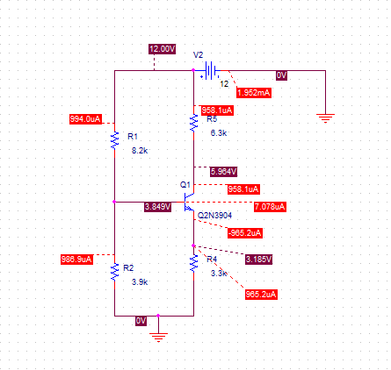

**2.)**

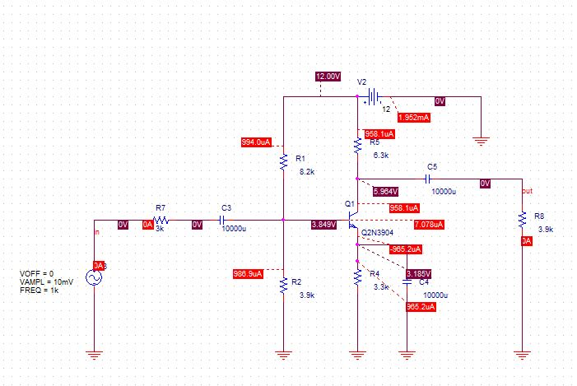



**3.)**

**a)**

${f }_{H}$***=***

${f }_{L}$**=**

**b)**

|  |  |
| --- | --- |
| Frequency | Vout |
| 30Hz | 288.624mV |
| 40Hz | 288.531mV |
| 50Hz | 287.157mV |
| 80Hz | 286.613mV |
| 150Hz | 280.090mV |
| 200Hz | 279.986mV |
| 250Hz | 277.998mV |
| 300Hz | 278.109mV |
| 500Hz | 277.848mV |
| 1kHz | 270.640mV |
| 10kHz | 280.136mV |
| 20kHz | 280.816mV |
| 60kHz | 279.957mV |
| 120kHz | 279.022mV |
| 200kHz | 276.352mV |
| 500kHz | 226.774mV |
| 750kHz | 179.425mV |
| 1MHz | 152.638mV |
| 1.3MHz | 125.401mV |
| 1.5MHz | 109.828mV |
|  |  |
|  |  |
|  |  |
|  |  |

**Measurement of Hİgh Cut-off and Low Cut-off Frequencies**

**4.)**

**a)**

$$A_{v-mid}=\frac{V_{out}}{V_{in}}= \frac{3.2529mV}{10mV}=0.3253$$



**b)**

${f }_{H}$***=***

${f }_{L}$**=**

**5.)**

$$R_{in}=$$



**6.)**

$$R_{out}=$$

